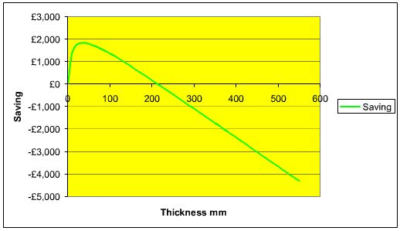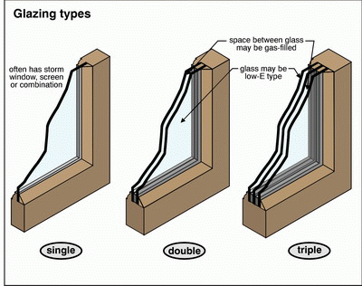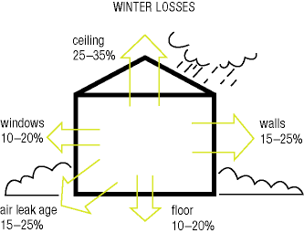

**Types of Heat Transfer**

There are three methods for heat transfer: conduction, convection and radiation. Knowing what each type is and how it works will give you a better understanding of how insulation and weatherstripping systems protect your conditioned space.

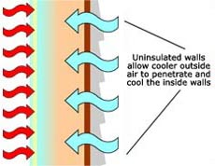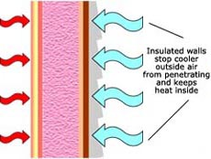**Conduction** is the transfer of heat through solid objects.

* Example: When it's cold outside, uninsulated walls and windows become cooler on the inside.
* Result: More energy is required to replace the heat lost warming the inside of the walls and windows.
* Preventive Measures: Insulation (fiberglass batts/rolls or blown cellulose), low-e insulated windows, storm windows and storm doors slow the migration of heat energy and help maintain the temperature in the conditioned space. Slowing the energy transfer saves on the amount of energy needed to maintain the conditioned space.

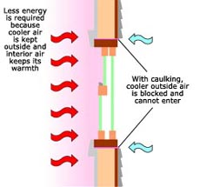**Convection** is the transfer of heat through liquids or gases.

* Example: When cold air enters your home it mixes with warm air. Heat energy is transferred to the cooler air and the overall temperature of the room is lowered.
* Result: More energy is required to replace the heat transferred to the cooler air.
* Preventive Measures: Weatherstripping, house wrap, caulk and expanding foam greatly reduce the uncontrolled flow of air into or out of your home. Reducing the uncontrolled flow of air into or out of the home reduces the amount of energy needed to heat unconditioned air.

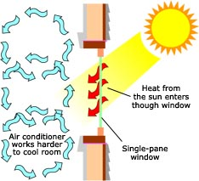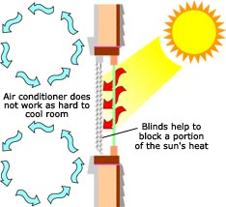**Radiation** is the transfer of heat through space in the form of electromagnetic energy.

* Example: When sunlight enters an air-conditioned room through a single pane window, heat energy is generated in the room.
* Result: The air conditioning system must run longer and work harder to overcome the heat gained through the window.
* Preventive Measures: Low-e insulated windows, blinds and awnings all lessen the heat gained by sunlight entering through windows.